SYSC 3303 Project Report

Lab Section 3, Group 5

Brandon Hartford

Darren Holden

Callum Kirby

Logan MacGillivray

Christopher Molnar

Contents

Team Member Responsibilities 1

Diagrams 3

Class Diagrams 3

Scheduler Subsystem 3

Floor Subsystem 3

Elevator Subsystem 4

Resources 5

Elevator State Machine 5

Timing Diagrams 6

Elevator Hard Error 6

Elevator Soft Error 6

Setup and Test Instructions 7

Measurement Results 8

Scheduability Analysis 8

Design Reflection 8

Schedular Subsystem 8

Elevator Subsystem 8

Floor Subsystem 9

# Team Member Responsibilities

The following tables (Tables 1 to 5 below) outline each team member’s responsibilities for each of the iterations.

|  |  |
| --- | --- |
| **Team Member** | **Responsibilities** |
| Brandon Hartford | * Programming the Floor system classes * Writing JUnit Test Cases * Documentation |
| Darren Holden | * Programming the Scheduler system classes * Writing documentation * Writing JUnit test cases * Performing end-to-end tests and debugging |
| Callum Kirby | * Programming the Elevator, ElevatorMotor, and ElevatorReciever * Writing JUnit Test Cases * Documentation |
| Logan MacGillivray | * Programming the Scheduler system classes * Drawing UML Class diagram |
| Christopher Molnar | * Programming SystemFile, Message, and Elevator State Machine * Created JUnit Tests * Writing documentation * Drawing the elevator state machine diagram |

Table 1: Iteration 1 Team Member Responsibilities

|  |  |
| --- | --- |
| **Team Member** | **Responsibilities** |
| Brandon Hartford | * Updating the Floor Subsystem |
| Darren Holden | * Updating the Scheduler subsystem |
| Callum Kirby | * Updating the Elevator subsystem |
| Logan MacGillivray | * Updating the README * Updating UML Class diagrams |
| Christopher Molnar | * Updating the Elevator subsystem * Elevator state machine diagram |

Table 2: Iteration 2 Team Member Responsibilities

|  |  |
| --- | --- |
| **Team Member** | **Responsibilities** |
| Brandon Hartford | * Timing Diagrams * Floor subsystem formatting cleanup |
| Darren Holden | * Debugging error modes * Preliminary performance timing |
| Callum Kirby | * Updating the Directions enum class * Automated test updates * UML class diagrams updates |
| Logan MacGillivray | * Updating the README * Updating UML Class diagrams |
| Christopher Molnar | * Implementing elevator error modes * Implementing error propagation through the system * Updating the state machine diagram |

Table 3: Iteration 3 Team Member Responsibilities

|  |  |
| --- | --- |
| **Team Member** | **Responsibilities** |
| Brandon Hartford | * Started work on the GUI |
| Darren Holden | * Error fixing * Improving timing accuracy |
| Callum Kirby | * Error fixing |
| Logan MacGillivray | * Updating UML Class diagrams |
| Christopher Molnar | * Error fixing * Updating the state machine diagram |

Table 4: Iteration 4 Team Member Responsibilities

|  |  |
| --- | --- |
| **Team Member** | **Responsibilities** |
| Brandon Hartford | * Working on the GUI |
| Darren Holden | * Testing * Writing JUnit tests * Writing the report |
| Callum Kirby | * Timing and Scheduling analysis * Summarizing Elevator subsystem |
| Logan MacGillivray | * Updating UML diagrams to include GUI |
| Christopher Molnar | * Assisted with timing and scheduling analysis * Assisted with GUI |

Table 5: Iteration 5 Team Member Responsibilities

# Diagrams

## Class Diagrams

### Scheduler Subsystem

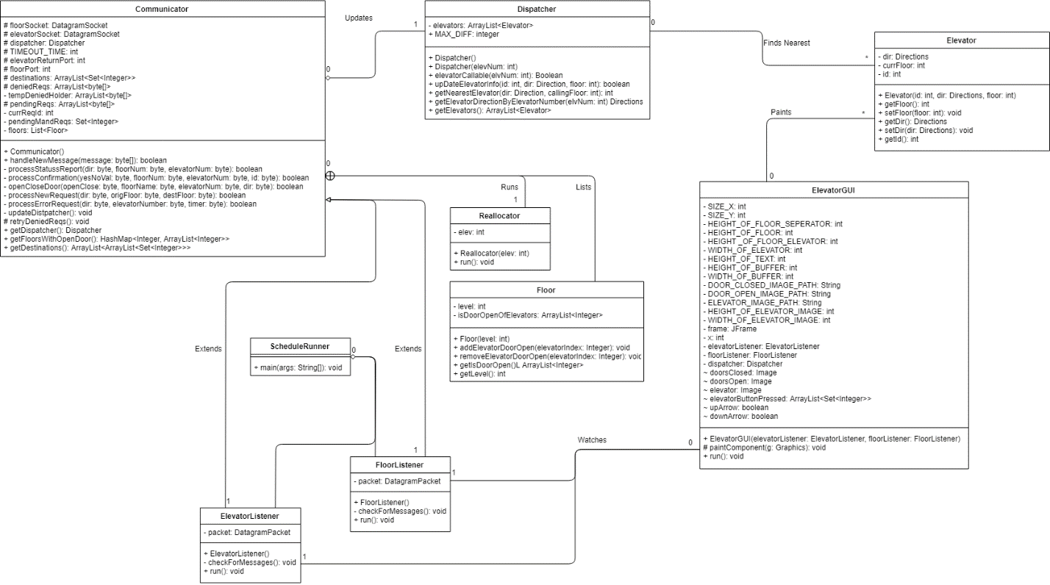

### Floor Subsystem

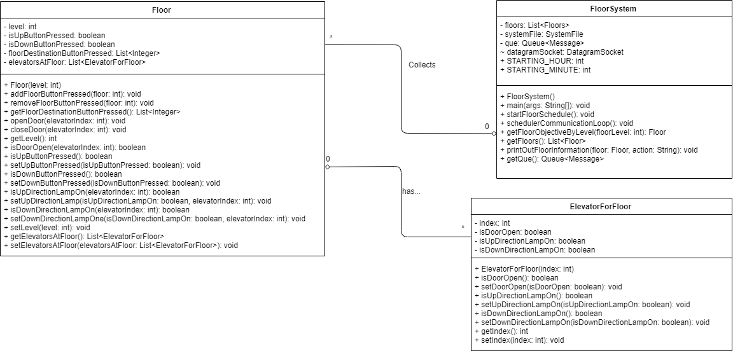

### Elevator Subsystem

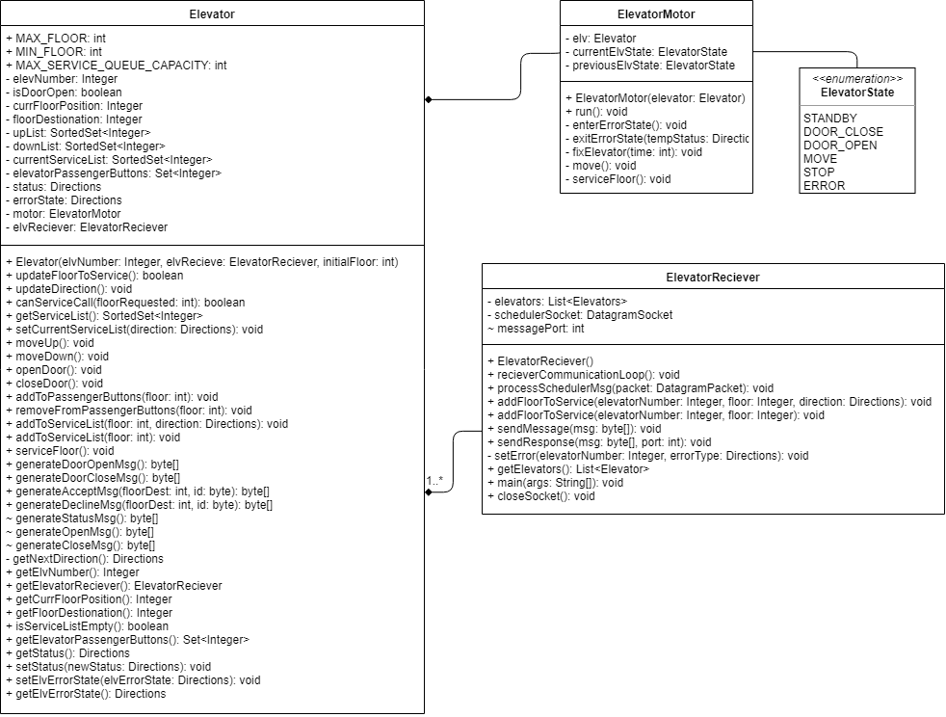

### Resources

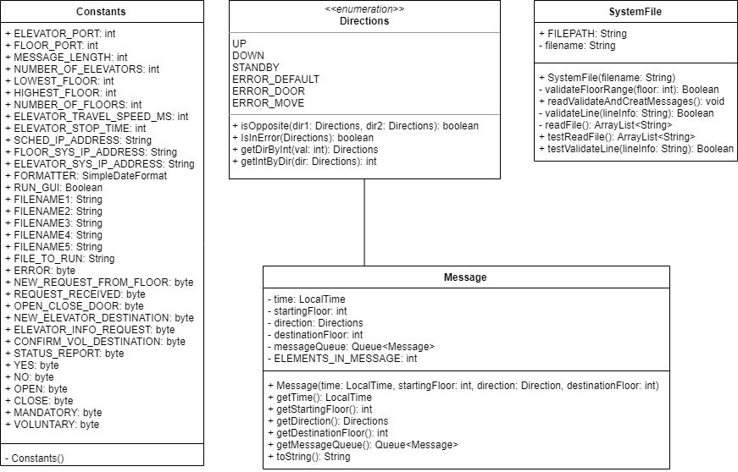

## Elevator State Machine

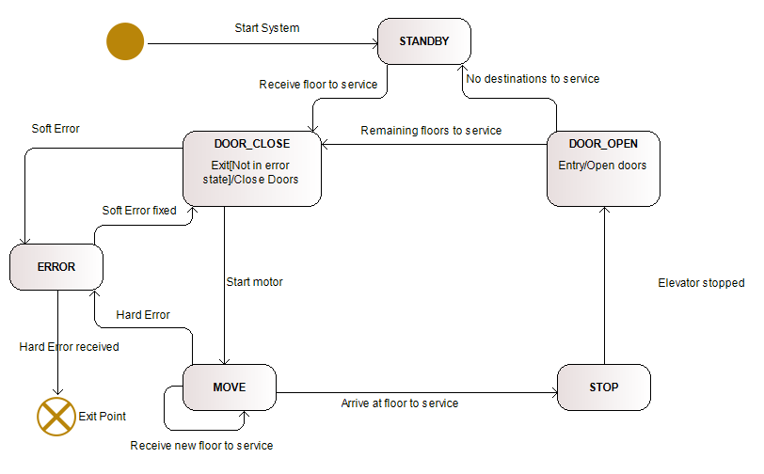

## Timing Diagrams

### Elevator Hard Error

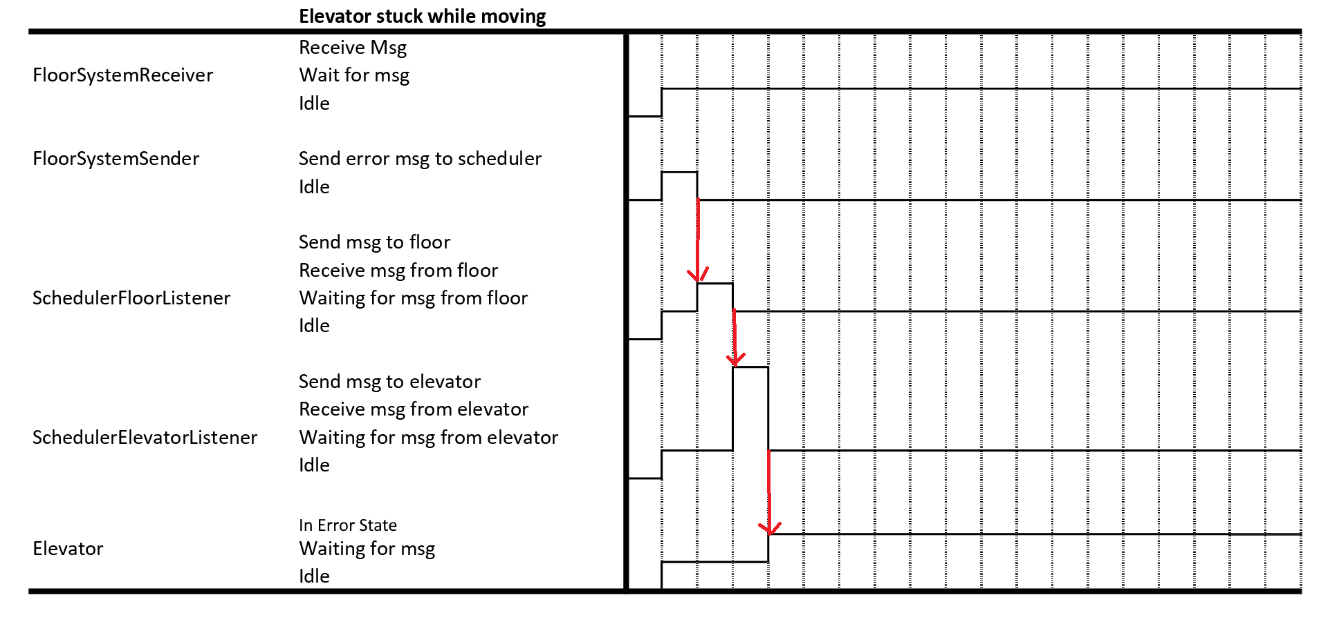

### Elevator Soft Error

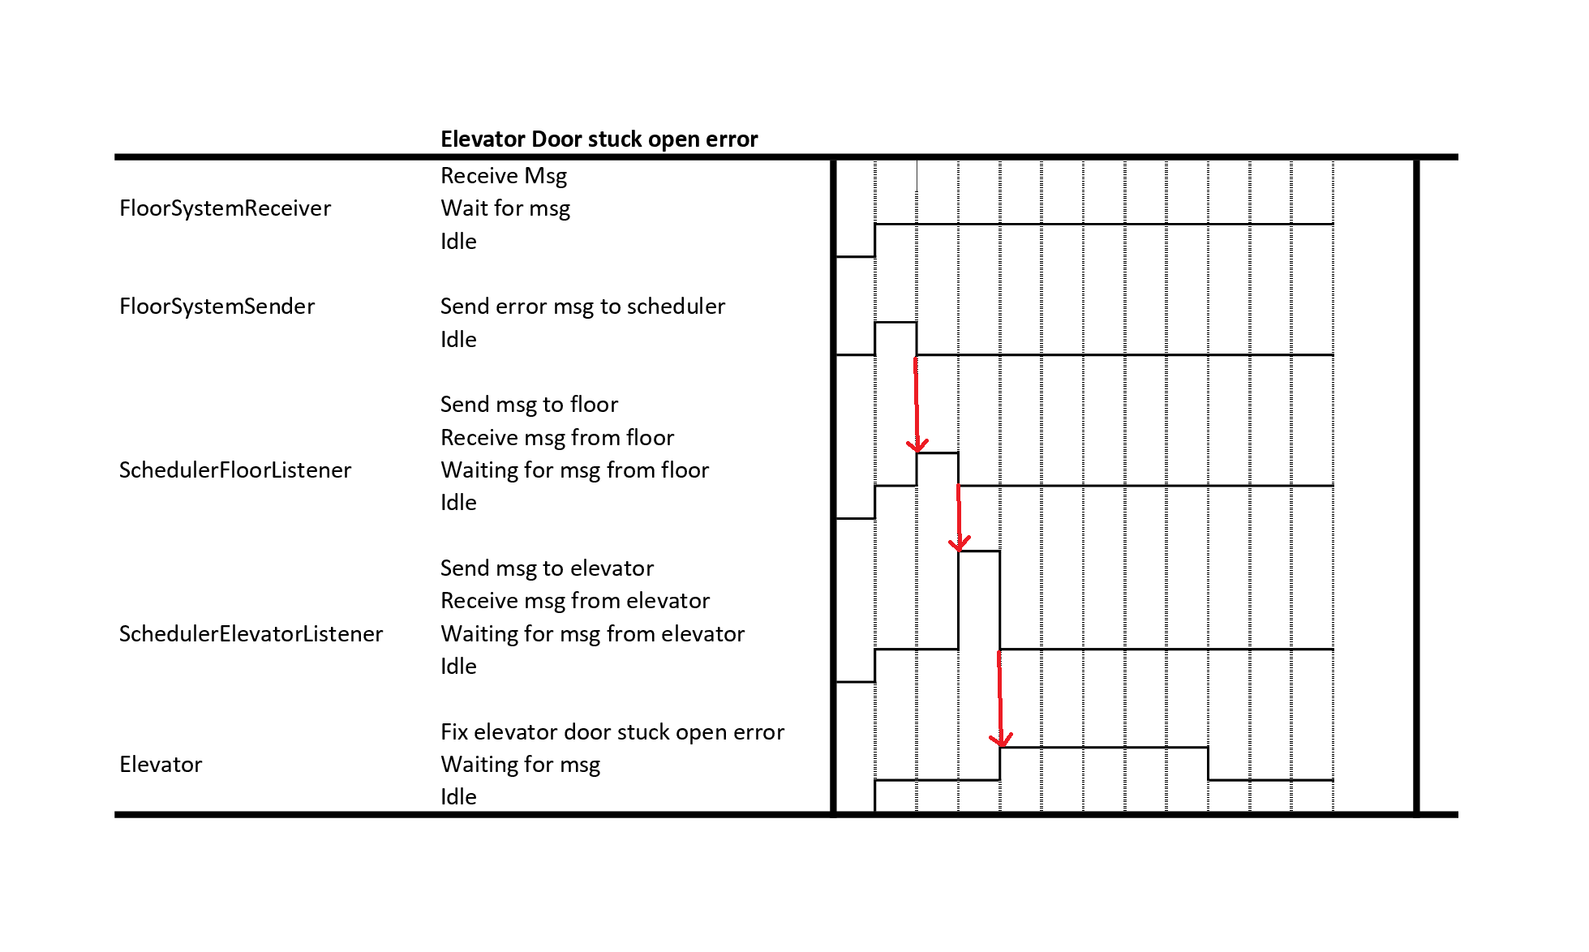

# Setup and Test Instructions

1. Unzip project
2. Import the Java project into Eclipse
   1. Open Eclipse
   2. Create a Java Project (file->new->Java Project)
   3. Give the Project a Name (e.g. ElevatorProjectGroup5) and Finish
   4. Import File (File -> Import), select General - File System and click Next
   5. Select Browse for Current Directory, and find the Java project "ElevatorProject" in the unzipped folder from step 1
   6. Check the box next to ElevatorProject box to import all of the files
   7. For the “Into Folder”, select the Java Project you created and hit finish
   8. If a popup asking if you want to overwrite the “.classpath” appears, select “Yes to All”
3. Navigate in the Package Explorer to the Java Project you imported the files into, and open src
   1. Open ElevatorReciever.java from the elevatorSubsystem package
   2. Open SchedulerRunner.java from the scheduler package
   3. Open FloorSystem.java from the floorSubsystem package
4. To run the system on multiple computers, follow the next instructions, otherwise skip to step 5
   1. Repeat Steps 1 to 3 on each computer that is to be used.
   2. In Eclipse, open resources.Constants.java and update the following values:
      1. SCHED_IP_ADDRESS - This should be the IP address of the computer that will run the Scheduler
      2. FLOOR_SYS_IP_ADDRESS - This should be the IP address of the computer that will run the Floor System
      3. ELEVATOR_SYS_IP_ADDRESS - This should be the IP address of the computer that will run the Elevator System
   3. Repeat step b on each computer that is being used
5. The execution of the elevator demo can be customized to enable or disable the visualizations of the GUI.
   1. To enable set the ‘RUN_GUI’ variable to ‘true’ in the constants Java file
   2. To enable set the ‘RUN_GUI’ variable to ‘false’ in the constants Java file
6. There are numerous testing files provided within the system to simulate different scenarios of elevator requests. These files can be found in the ‘resources’ folder.
   1. To set a file as input change the ‘FILE_TO_RUN’ variable to the desired file name within the ‘resources’ directory
7. To run our project run ElevatorReciever.java, SchedulerRunner.java and floorSystem.java (in that order)
   1. The ElevatorReciever output will show the progress of the elevator (where its going and what state its in)
   2. The SchedulerRunner output will show the scheduler system processing requests
   3. The FloorSystem output will show the floor system sending new requests, as well as the status of the floors as they get updated
8. To access the JUnit tests, navigate to any package the is preceded with “test.”
   1. The JUnit tests are organized by the subsystem or component that they correspond to
      1. This is denoted in the package name
   2. To run a JUnit Test, navigate to the desired JUnit file and select “Run as…” and then “JUnit”

# Measurement Results

# Scheduability Analysis

# Design Reflection

## Schedular Subsystem

One thing that is good about it is that it has threads to separately listen to the floor and elevator subsystems. This gives the system some flexibility and allows it deal with the two systems in different ways.

One thing that might have been changed would be to have each of the scheduler processes run as a different thread. This would allow different priorities to be set to different tasks, which would allow the schedular to handle certain tasks quicker or slower as need be. This would have a performance impact, especially if the schedular received a burst of many messages all at once. Testing would have to be done to determine if the benefits are worst the cost.

The structures for maintaining pending requests and final elevator destinations are a bit complicated. It may have been possible to use a less convoluted method for tracking this information, perhaps with a specially constructed class.

## Elevator Subsystem

We were contenting in the compatibility of the elevator subsystem and being able to clearly break it into three keys parts – Motor, Listener, and State Machine. All of these were compacted into a standard ‘Elevator’ object allowing us to easily test the class at run time.

Breaking the elevator apart this way allowed for us to run more efficient elevator timing wise, as the elevator needed to be able to both listen for new communication from the scheduler, as well as move to service current requests. Breaking the subsystem into these two main threads allowed us to better simulate how a real elevator system would work.

Because the elevator object is constructed on these subclasses, it involves a lot of method calls outside of the class – which can get a little difficult traceability wise for someone who is not familiar with the system. To improve on the design of the subsystem, designing the elevator with this in mind and clearly identifying method names would be preferred. Otherwise, we believe the elevators operate in an optimal way.

## Floor Subsystem